Android Application Development Lab
Name : Basiru Mbye
Roll No. - 25/SCA/MCAN/008

Q1 -> Create an application that takes the name from a text box and shows a hello message along with the name entered in the text box, when the user clicks the OK button.

Ans1 ->

Xml -
<?xml version="1.0" encoding="utf-8"?>
<LinearLayout xmlns:android="http://schemas.android.com/apk/res/android"
android:layout_width="match_parent"
android:layout_height="match_parent"
android:orientation="vertical"
android:padding="24dp"
android:gravity="center">

<EditText
android:id="@+id/etName"
android:layout_width="match_parent"
android:layout_height="wrap_content"
android:hint="Enter your name"
android:inputType="textPersonName"/>

<Button
android:id="@+id/btnOK"
android:layout_width="wrap_content"
android:layout_height="wrap_content"
android:layout_marginTop="16dp"
android:text="OK"/>

<TextView
android:id="@+id/tvHello"
android:layout_width="wrap_content"
android:layout_height="wrap_content"
android:layout_marginTop="24dp"
android:textSize="20sp"
android:textStyle="bold"
android:text=""/>

</LinearLayout>
Java -
package com.example.a1_user_input;

import androidx.appcompat.app.AppCompatActivity;
import android.os.Bundle;
import android.view.View;
import android.widget.Button;
import android.widget.EditText;
import android.widget.TextView;

public class MainActivity extends AppCompatActivity {

EditText etName;
Button btnOK;
TextView tvHello;

@Override
protected void onCreate(Bundle savedInstanceState) {
super.onCreate(savedInstanceState);
setContentView(R.layout.activity_main);

etName = findViewById(R.id.etName);
btnOK = findViewById(R.id.btnOK);
tvHello = findViewById(R.id.tvHello);

btnOK.setOnClickListener(new View.OnClickListener() {
@Override
public void onClick(View v) {
String name = etName.getText().toString().trim();
if (!name.isEmpty()) {
tvHello.setText("Hello, " + name + "!");
} else {
tvHello.setText("Please enter a name.");
}
}
});
}
}

Output -
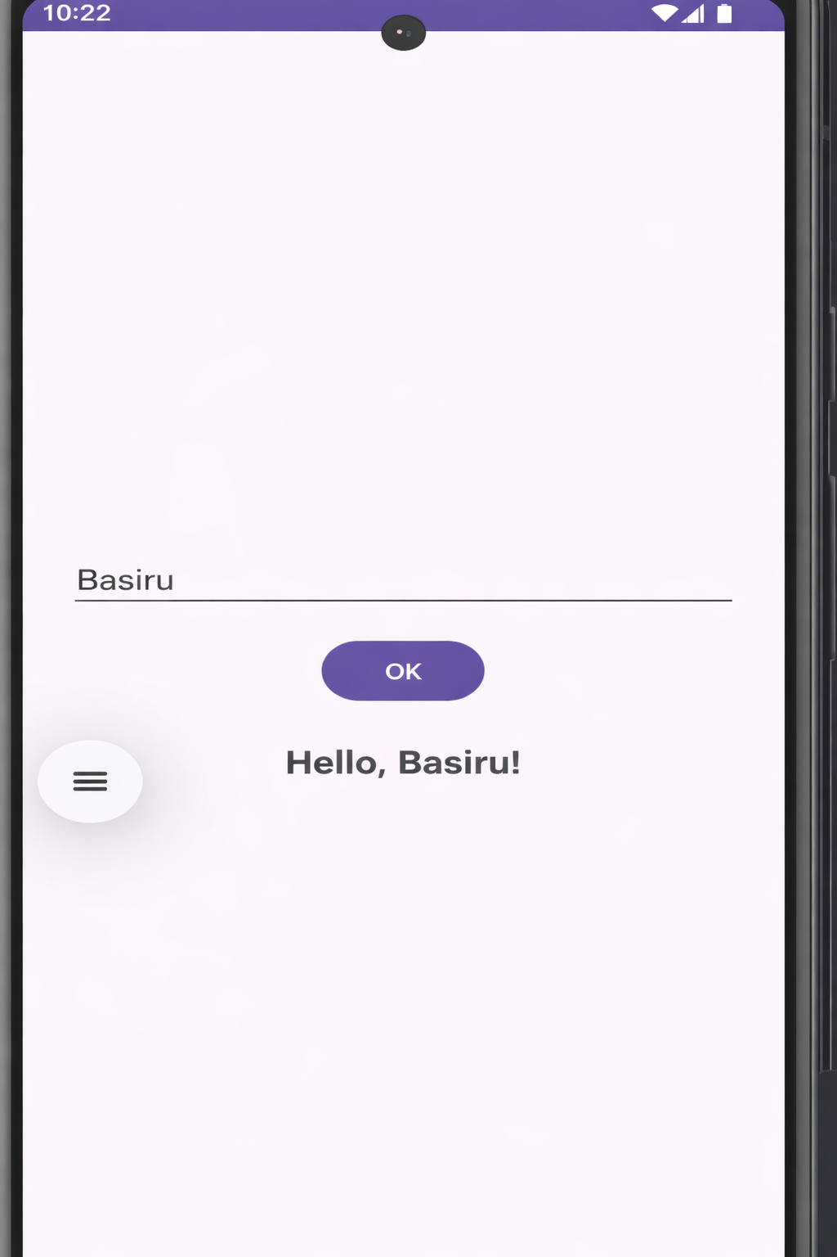

Q2 -> Create a screen that has input boxes for User Name, Password, Address, Gender (radio buttons for male and female), Age (numeric), Date of Birth (Date Picket), State (Spinner) and a Submit button. On clicking the submit button, print all the data below the Submit Button. Use 1. Linear Layout, 2. Relative Lavout and 3. Grid Layout or Table Layout.

Ans2 ->

Java -
package com.example.formapp;

import androidx.appcompat.app.AppCompatActivity;
import android.os.Bundle;
import android.view.View;
import android.widget.*;

public class MainActivity extends AppCompatActivity {

EditText etName, etPassword, etAddress, etAge;
RadioGroup rgGender;
DatePicker dpDOB;
Spinner spState;
Button btnSubmit;
TextView tvResult;

@Override
protected void onCreate(Bundle savedInstanceState) {
super.onCreate(savedInstanceState);
setContentView(R.layout.activity_main); // swap XML here

etName = findViewById(R.id.etName);
etPassword = findViewById(R.id.etPassword);
etAddress = findViewById(R.id.etAddress);
etAge = findViewById(R.id.etAge);
rgGender = findViewById(R.id.rgGender);
dpDOB = findViewById(R.id.dpDOB);
spState = findViewById(R.id.spState);
btnSubmit = findViewById(R.id.btnSubmit);
tvResult = findViewById(R.id.tvResult);

// Populate spinner
String[] states = {"Delhi", "Haryana", "UP", "Maharashtra", "Karnataka"};
ArrayAdapter<String> adapter = new ArrayAdapter<>(this,
android.R.layout.simple_spinner_item, states);
adapter.setDropDownViewResource(android.R.layout.simple_spinner_dropdown_item);
spState.setAdapter(adapter);

btnSubmit.setOnClickListener(new View.OnClickListener() {
@Override
public void onClick(View v) {
String name = etName.getText().toString();
String password = etPassword.getText().toString();
String address = etAddress.getText().toString();
String age = etAge.getText().toString();
String state = spState.getSelectedItem().toString();

int selectedGenderId = rgGender.getCheckedRadioButtonId();
RadioButton rbGender = findViewById(selectedGenderId);
String gender = (rbGender != null) ? rbGender.getText().toString() : "Not selected";

String dob = dpDOB.getDayOfMonth() + "/" +
(dpDOB.getMonth() + 1) + "/" +
dpDOB.getYear();

tvResult.setText(
"Name: " + name + "\n" +
"Password: " + password + "\n" +
"Address: " + address + "\n" +
"Gender: " + gender + "\n" +
"Age: " + age + "\n" +
"DOB: " + dob + "\n" +
"State: " + state
);
}
});
}
}

Xml (Linear Layout) -

<?xml version="1.0" encoding="utf-8"?>
<ScrollView xmlns:android="http://schemas.android.com/apk/res/android"
android:layout_width="match_parent"
android:layout_height="match_parent">

<LinearLayout
android:layout_width="match_parent"
android:layout_height="wrap_content"
android:orientation="vertical"
android:padding="16dp">

<TextView android:text="User Name" android:layout_width="wrap_content" android:layout_height="wrap_content"/>
<EditText android:id="@+id/etName" android:layout_width="match_parent" android:layout_height="wrap_content" android:hint="Enter name"/>

<TextView android:text="Password" android:layout_width="wrap_content" android:layout_height="wrap_content" android:layout_marginTop="8dp"/>
<EditText android:id="@+id/etPassword" android:layout_width="match_parent" android:layout_height="wrap_content" android:inputType="textPassword" android:hint="Enter password"/>

<TextView android:text="Address" android:layout_width="wrap_content" android:layout_height="wrap_content" android:layout_marginTop="8dp"/>
<EditText android:id="@+id/etAddress" android:layout_width="match_parent" android:layout_height="wrap_content" android:hint="Enter address"/>

<TextView android:text="Gender" android:layout_width="wrap_content" android:layout_height="wrap_content" android:layout_marginTop="8dp"/>
<RadioGroup android:id="@+id/rgGender" android:orientation="horizontal" android:layout_width="wrap_content" android:layout_height="wrap_content">
<RadioButton android:id="@+id/rbMale" android:text="Male" android:layout_width="wrap_content" android:layout_height="wrap_content"/>
<RadioButton android:id="@+id/rbFemale" android:text="Female" android:layout_width="wrap_content" android:layout_height="wrap_content"/>
</RadioGroup>

<TextView android:text="Age" android:layout_width="wrap_content" android:layout_height="wrap_content" android:layout_marginTop="8dp"/>
<EditText android:id="@+id/etAge" android:layout_width="match_parent" android:layout_height="wrap_content" android:inputType="number" android:hint="Enter age"/>

<TextView android:text="Date of Birth" android:layout_width="wrap_content" android:layout_height="wrap_content" android:layout_marginTop="8dp"/>
<DatePicker android:id="@+id/dpDOB" android:layout_width="wrap_content" android:layout_height="wrap_content" android:calendarViewShown="false"/>

<TextView android:text="State" android:layout_width="wrap_content" android:layout_height="wrap_content" android:layout_marginTop="8dp"/>
<Spinner android:id="@+id/spState" android:layout_width="match_parent" android:layout_height="wrap_content"/>

<Button android:id="@+id/btnSubmit" android:layout_width="match_parent" android:layout_height="wrap_content" android:layout_marginTop="16dp" android:text="Submit"/>

<TextView android:id="@+id/tvResult" android:layout_width="wrap_content" android:layout_height="wrap_content" android:layout_marginTop="16dp" android:textSize="15sp"/>

</LinearLayout>
</ScrollView>

Output -
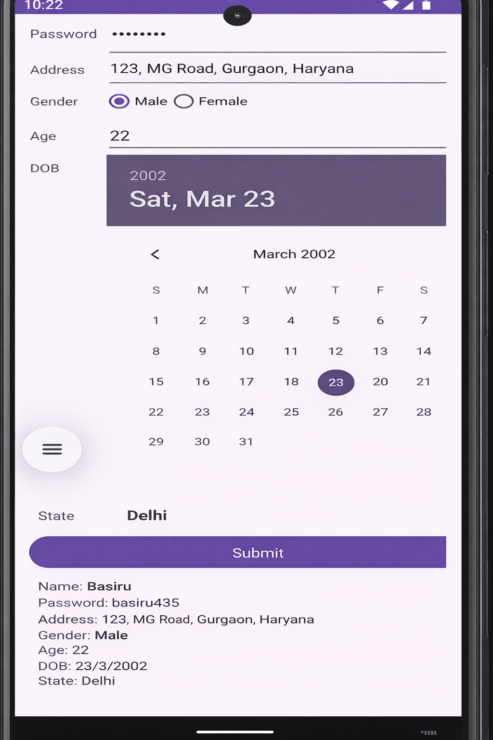

Xml (Relative Layout) -

<?xml version="1.0" encoding="utf-8"?>
<ScrollView xmlns:android="http://schemas.android.com/apk/res/android"
android:layout_width="match_parent"
android:layout_height="match_parent">

<RelativeLayout
android:layout_width="match_parent"
android:layout_height="wrap_content"
android:padding="16dp">

<TextView android:id="@+id/lblName" android:text="User Name"
android:layout_width="wrap_content" android:layout_height="wrap_content"/>
<EditText android:id="@+id/etName" android:hint="Enter name"
android:layout_width="match_parent" android:layout_height="wrap_content"
android:layout_below="@id/lblName"/>

<TextView android:id="@+id/lblPassword" android:text="Password"
android:layout_width="wrap_content" android:layout_height="wrap_content"
android:layout_below="@id/etName" android:layout_marginTop="8dp"/>
<EditText android:id="@+id/etPassword" android:hint="Enter password"
android:inputType="textPassword"
android:layout_width="match_parent" android:layout_height="wrap_content"
android:layout_below="@id/lblPassword"/>

<TextView android:id="@+id/lblAddress" android:text="Address"
android:layout_width="wrap_content" android:layout_height="wrap_content"
android:layout_below="@id/etPassword" android:layout_marginTop="8dp"/>
<EditText android:id="@+id/etAddress" android:hint="Enter address"
android:layout_width="match_parent" android:layout_height="wrap_content"
android:layout_below="@id/lblAddress"/>

<TextView android:id="@+id/lblGender" android:text="Gender"
android:layout_width="wrap_content" android:layout_height="wrap_content"
android:layout_below="@id/etAddress" android:layout_marginTop="8dp"/>
<RadioGroup android:id="@+id/rgGender" android:orientation="horizontal"
android:layout_width="wrap_content" android:layout_height="wrap_content"
android:layout_below="@id/lblGender">
<RadioButton android:id="@+id/rbMale" android:text="Male"
android:layout_width="wrap_content" android:layout_height="wrap_content"/>
<RadioButton android:id="@+id/rbFemale" android:text="Female"
android:layout_width="wrap_content" android:layout_height="wrap_content"/>
</RadioGroup>

<TextView android:id="@+id/lblAge" android:text="Age"
android:layout_width="wrap_content" android:layout_height="wrap_content"
android:layout_below="@id/rgGender" android:layout_marginTop="8dp"/>
<EditText android:id="@+id/etAge" android:hint="Enter age"
android:inputType="number"
android:layout_width="match_parent" android:layout_height="wrap_content"
android:layout_below="@id/lblAge"/>

<TextView android:id="@+id/lblDOB" android:text="Date of Birth"
android:layout_width="wrap_content" android:layout_height="wrap_content"
android:layout_below="@id/etAge" android:layout_marginTop="8dp"/>
<DatePicker android:id="@+id/dpDOB"
android:layout_width="wrap_content" android:layout_height="wrap_content"
android:calendarViewShown="false"
android:layout_below="@id/lblDOB"/>

<TextView android:id="@+id/lblState" android:text="State"
android:layout_width="wrap_content" android:layout_height="wrap_content"
android:layout_below="@id/dpDOB" android:layout_marginTop="8dp"/>
<Spinner android:id="@+id/spState"
android:layout_width="match_parent" android:layout_height="wrap_content"
android:layout_below="@id/lblState"/>

<Button android:id="@+id/btnSubmit" android:text="Submit"
android:layout_width="match_parent" android:layout_height="wrap_content"
android:layout_below="@id/spState" android:layout_marginTop="16dp"/>

<TextView android:id="@+id/tvResult"
android:layout_width="wrap_content" android:layout_height="wrap_content"
android:layout_below="@id/btnSubmit" android:layout_marginTop="16dp"
android:textSize="15sp"/>

</RelativeLayout>
</ScrollView>

Output -



Xml (Table Layout) -

<?xml version="1.0" encoding="utf-8"?>
<ScrollView xmlns:android="http://schemas.android.com/apk/res/android"
android:layout_width="match_parent"
android:layout_height="match_parent">

<TableLayout
android:layout_width="match_parent"
android:layout_height="wrap_content"
android:padding="16dp"
android:stretchColumns="1">

<TableRow>
<TextView android:text="User Name" android:padding="8dp"/>
<EditText android:id="@+id/etName" android:hint="Enter name"/>
</TableRow>

<TableRow>
<TextView android:text="Password" android:padding="8dp"/>
<EditText android:id="@+id/etPassword" android:hint="Enter password" android:inputType="textPassword"/>
</TableRow>

<TableRow>
<TextView android:text="Address" android:padding="8dp"/>
<EditText android:id="@+id/etAddress" android:hint="Enter address"/>
</TableRow>

<TableRow>
<TextView android:text="Gender" android:padding="8dp"/>
<RadioGroup android:id="@+id/rgGender" android:orientation="horizontal">
<RadioButton android:id="@+id/rbMale" android:text="Male"/>
<RadioButton android:id="@+id/rbFemale" android:text="Female"/>
</RadioGroup>
</TableRow>

<TableRow>
<TextView android:text="Age" android:padding="8dp"/>
<EditText android:id="@+id/etAge" android:hint="Enter age" android:inputType="number"/>
</TableRow>

<TableRow>
<TextView android:text="DOB" android:padding="8dp"/>
<DatePicker android:id="@+id/dpDOB" android:calendarViewShown="false"/>
</TableRow>

<TableRow>
<TextView android:text="State" android:padding="8dp"/>
<Spinner android:id="@+id/spState"/>
</TableRow>

<TableRow>
<Button android:id="@+id/btnSubmit" android:text="Submit"
android:layout_span="2" android:layout_width="match_parent"/>
</TableRow>

<TableRow>
<TextView android:id="@+id/tvResult" android:layout_span="2"
android:padding="8dp" android:textSize="15sp"/>
</TableRow>

</TableLayout>
</ScrollView>

Output -



Q3 -> Develop an application that inserts some notifications into the Notification area and whenever a notification is inserted, it should show a toast with details of the notification.

Ans3 ->

Xml -
<?xml version="1.0" encoding="utf-8"?>
<LinearLayout xmlns:android="http://schemas.android.com/apk/res/android"
android:layout_width="match_parent"
android:layout_height="match_parent"
android:orientation="vertical"
android:gravity="center"
android:padding="24dp">

<EditText
android:id="@+id/etTitle"
android:layout_width="match_parent"
android:layout_height="wrap_content"
android:hint="Notification Title"/>

<EditText
android:id="@+id/etMessage"
android:layout_width="match_parent"
android:layout_height="wrap_content"
android:hint="Notification Message"
android:layout_marginTop="12dp"/>

<Button
android:id="@+id/btnSend"
android:layout_width="wrap_content"
android:layout_height="wrap_content"
android:layout_marginTop="20dp"
android:text="Send Notification"/>

</LinearLayout>

Java -
package com.example.q3notification;

import androidx.appcompat.app.AppCompatActivity;
import androidx.core.app.NotificationCompat;
import androidx.core.app.NotificationManagerCompat;
import android.app.NotificationChannel;
import android.app.NotificationManager;
import android.os.Build;
import android.os.Bundle;
import android.view.View;
import android.widget.Button;
import android.widget.EditText;
import android.widget.Toast;

public class MainActivity extends AppCompatActivity {

EditText etTitle, etMessage;
Button btnSend;

private static final String CHANNEL_ID = "my_channel";
private static int notificationId = 0;

@Override
protected void onCreate(Bundle savedInstanceState) {
super.onCreate(savedInstanceState);
setContentView(R.layout.activity_main);

etTitle = findViewById(R.id.etTitle);
etMessage = findViewById(R.id.etMessage);
btnSend = findViewById(R.id.btnSend);

createNotificationChannel();

btnSend.setOnClickListener(new View.OnClickListener() {
@Override
public void onClick(View v) {
String title = etTitle.getText().toString().trim();
String message = etMessage.getText().toString().trim();

if (title.isEmpty() || message.isEmpty()) {
Toast.makeText(MainActivity.this,
"Please enter title and message", Toast.LENGTH_SHORT).show();
return;
}

// Build and show notification
NotificationCompat.Builder builder = new NotificationCompat.Builder(
MainActivity.this, CHANNEL_ID)
.setSmallIcon(android.R.drawable.ic_dialog_info)
.setContentTitle(title)
.setContentText(message)
.setPriority(NotificationCompat.PRIORITY_HIGH)
.setAutoCancel(true);

NotificationManagerCompat notificationManager =
NotificationManagerCompat.from(MainActivity.this);
notificationManager.notify(notificationId++, builder.build());

// Show Toast with notification details
Toast.makeText(MainActivity.this,
"Notification Sent!\nTitle: " + title + "\nMessage: " + message,
Toast.LENGTH_LONG).show();
}
});
}

private void createNotificationChannel() {
if (Build.VERSION.SDK_INT >= Build.VERSION_CODES.O) {
CharSequence name = "My Channel";
String description = "Channel for app notifications";
int importance = NotificationManager.IMPORTANCE_HIGH;
NotificationChannel channel = new NotificationChannel(CHANNEL_ID, name, importance);
channel.setDescription(description);

NotificationManager notificationManager =
getSystemService(NotificationManager.class);
notificationManager.createNotificationChannel(channel);
}
}
}

Output -

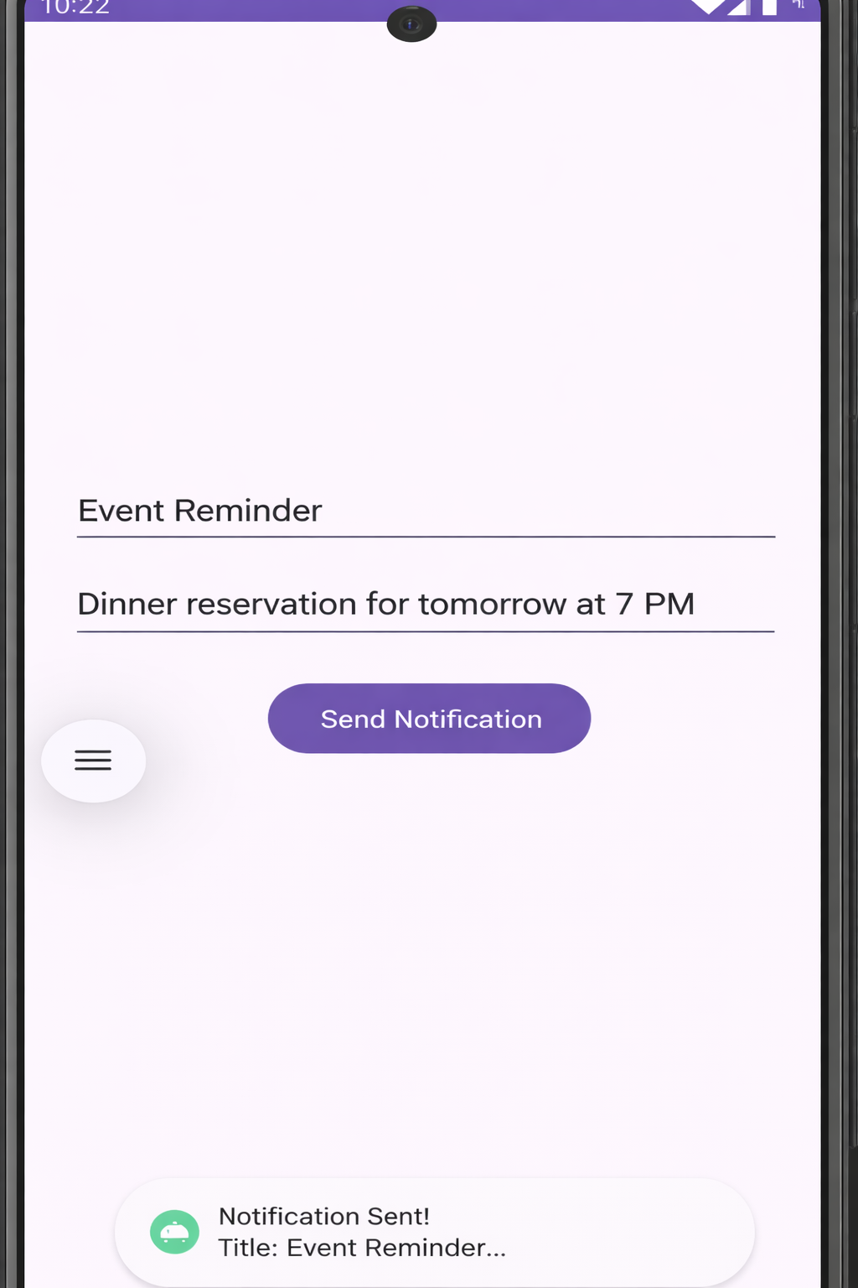
Q4 -> Develop an application that uses a menu with 3 options for dialing a number, opening a website and to send an SMS. On selecting an option, the appropriate action should be invoked using intents.

Ans4 ->

Xml -

<?xml version="1.0" encoding="utf-8"?>
<LinearLayout xmlns:android="http://schemas.android.com/apk/res/android"
android:layout_width="match_parent"
android:layout_height="match_parent"
android:orientation="vertical">

<androidx.appcompat.widget.Toolbar
android:id="@+id/toolbar"
android:layout_width="match_parent"
android:layout_height="?attr/actionBarSize"
android:background="?attr/colorPrimary"
android:title="Q4 Menu App"/>

<TextView
android:layout_width="match_parent"
android:layout_height="match_parent"
android:gravity="center"
android:text="Press the 3-dot menu (top right)"
android:textSize="18sp"/>

</LinearLayout>

Java -
package com.example.q4menu;

import androidx.appcompat.app.AppCompatActivity;
import android.content.Intent;
import android.net.Uri;
import android.os.Bundle;
import android.view.Menu;
import android.view.MenuItem;
import android.widget.Toast;
import androidx.appcompat.widget.Toolbar;

public class MainActivity extends AppCompatActivity {

@Override
protected void onCreate(Bundle savedInstanceState) {
super.onCreate(savedInstanceState);
setContentView(R.layout.activity_main);
Toolbar toolbar = findViewById(R.id.toolbar);
setSupportActionBar(toolbar);
}

// Inflate the menu
@Override
public boolean onCreateOptionsMenu(Menu menu) {
getMenuInflater().inflate(R.menu.menu_main, menu);
return true;
}

// Handle menu item clicks
@Override
public boolean onOptionsItemSelected(MenuItem item) {
int id = item.getItemId();

if (id == R.id.menu_dial) {
// Dial a number
Intent dialIntent = new Intent(Intent.ACTION_DIAL);
dialIntent.setData(Uri.parse("tel:9876543210"));
startActivity(dialIntent);
return true;

} else if (id == R.id.menu_website) {
// Open a website
Intent webIntent = new Intent(Intent.ACTION_VIEW);
webIntent.setData(Uri.parse("https://www.google.com"));
startActivity(webIntent);
return true;

} else if (id == R.id.menu_sms) {
// Send an SMS
Intent smsIntent = new Intent(Intent.ACTION_SENDTO);
smsIntent.setData(Uri.parse("smsto:9876543210"));
smsIntent.putExtra("sms_body", "Hello! This is a test SMS.");
startActivity(smsIntent);
return true;
}

return super.onOptionsItemSelected(item);
}
}

Output -
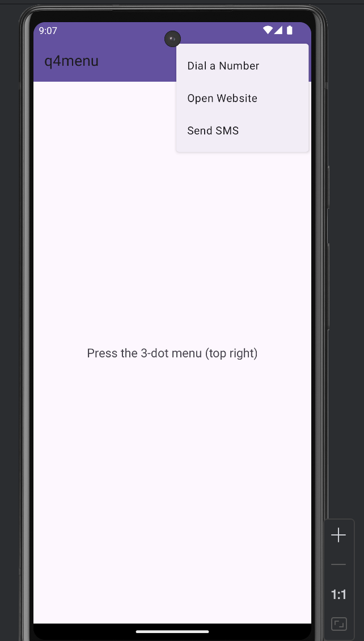

Q5 -> Create an application that uses a text file to store user names and passwords (tab separated fields and one record per line) When the user submits a login name and password through a screen, the details should be verified with the text file data and if they match, show a dialog saying that login is successful. Otherwise, show the dialog with a Login Failed message.

Ans5 ->

Xml -

<?xml version="1.0" encoding="utf-8"?>
<LinearLayout xmlns:android="http://schemas.android.com/apk/res/android"
android:layout_width="match_parent"
android:layout_height="match_parent"
android:orientation="vertical"
android:gravity="center"
android:padding="24dp">

<TextView
android:layout_width="wrap_content"
android:layout_height="wrap_content"
android:text="Login"
android:textSize="28sp"
android:textStyle="bold"
android:layout_marginBottom="24dp"/>

<EditText
android:id="@+id/etUsername"
android:layout_width="match_parent"
android:layout_height="wrap_content"
android:hint="Enter Username"
android:inputType="textPersonName"/>

<EditText
android:id="@+id/etPassword"
android:layout_width="match_parent"
android:layout_height="wrap_content"
android:hint="Enter Password"
android:inputType="textPassword"
android:layout_marginTop="12dp"/>

<Button
android:id="@+id/btnLogin"
android:layout_width="match_parent"
android:layout_height="wrap_content"
android:layout_marginTop="20dp"
android:text="Login"/>

<Button
android:id="@+id/btnRegister"
android:layout_width="match_parent"
android:layout_height="wrap_content"
android:layout_marginTop="8dp"
android:text="Register (Save User)"/>

</LinearLayout>

Java -

package com.example.q5login;

import androidx.appcompat.app.AlertDialog;
import androidx.appcompat.app.AppCompatActivity;
import android.os.Bundle;
import android.view.View;
import android.widget.Button;
import android.widget.EditText;
import android.widget.Toast;
import java.io.*;

public class MainActivity extends AppCompatActivity {

EditText etUsername, etPassword;
Button btnLogin, btnRegister;
private static final String FILE_NAME = "users.txt";

@Override
protected void onCreate(Bundle savedInstanceState) {
super.onCreate(savedInstanceState);
setContentView(R.layout.activity_main);

etUsername = findViewById(R.id.etUsername);
etPassword = findViewById(R.id.etPassword);
btnLogin = findViewById(R.id.btnLogin);
btnRegister = findViewById(R.id.btnRegister);

// Save new user to text file
btnRegister.setOnClickListener(new View.OnClickListener() {
@Override
public void onClick(View v) {
String username = etUsername.getText().toString().trim();
String password = etPassword.getText().toString().trim();

if (username.isEmpty() || password.isEmpty()) {
Toast.makeText(MainActivity.this,
"Please enter username and password", Toast.LENGTH_SHORT).show();
return;
}

try {
FileOutputStream fos = openFileOutput(FILE_NAME, MODE_APPEND);
String record = username + "\t" + password + "\n";
fos.write(record.getBytes());
fos.close();
Toast.makeText(MainActivity.this,
"User registered successfully!", Toast.LENGTH_SHORT).show();
} catch (IOException e) {
e.printStackTrace();
}
}
});

// Verify login from text file
btnLogin.setOnClickListener(new View.OnClickListener() {
@Override
public void onClick(View v) {
String username = etUsername.getText().toString().trim();
String password = etPassword.getText().toString().trim();

if (username.isEmpty() || password.isEmpty()) {
Toast.makeText(MainActivity.this,
"Please enter username and password", Toast.LENGTH_SHORT).show();
return;
}

boolean loginSuccess = false;

try {
FileInputStream fis = openFileInput(FILE_NAME);
BufferedReader reader = new BufferedReader(new InputStreamReader(fis));
String line;

while ((line = reader.readLine()) != null) {
String[] parts = line.split("\t");
if (parts.length == 2) {
String savedUser = parts[0].trim();
String savedPass = parts[1].trim();
if (savedUser.equals(username) && savedPass.equals(password)) {
loginSuccess = true;
break;
}
}
}
reader.close();
fis.close();

} catch (FileNotFoundException e) {
showDialog("Login Failed", "No users registered yet!");
return;
} catch (IOException e) {
e.printStackTrace();
}

if (loginSuccess) {
showDialog("Login Successful", "Welcome, " + username + "!");
} else {
showDialog("Login Failed", "Invalid username or password.");
}
}
});
}

private void showDialog(String title, String message) {
new AlertDialog.Builder(this)
.setTitle(title)
.setMessage(message)
.setPositiveButton("OK", null)
.show();
}
}

Output -

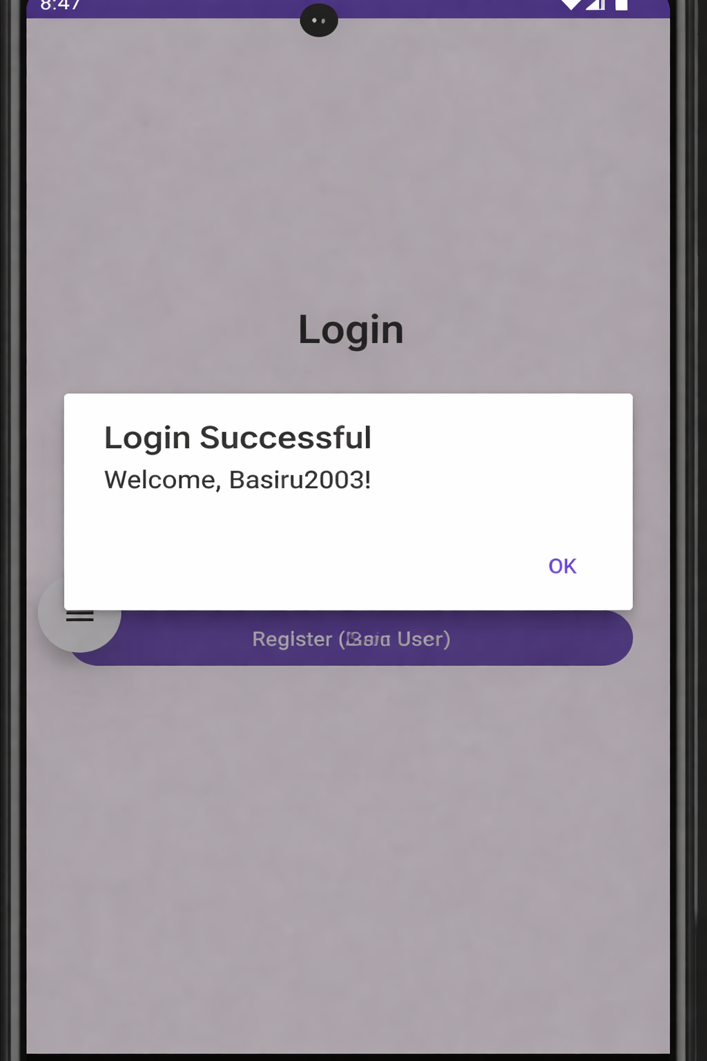
Q6 -> Create an activity to navigate to different activities through Intents-Implicit and Explicit.

Ans6 ->

Xml -
<?xml version="1.0" encoding="utf-8"?>
<LinearLayout xmlns:android="http://schemas.android.com/apk/res/android"
android:layout_width="match_parent"
android:layout_height="match_parent"
android:orientation="vertical"
android:gravity="center"
android:padding="24dp">

<TextView
android:layout_width="wrap_content"
android:layout_height="wrap_content"
android:text="Intent Navigation Demo"
android:textSize="22sp"
android:textStyle="bold"
android:layout_marginBottom="32dp"/>

<Button
android:id="@+id/btnExplicit"
android:layout_width="match_parent"
android:layout_height="wrap_content"
android:text="Explicit Intent (Go to Second Activity)"/>

<Button
android:id="@+id/btnImplicitWeb"
android:layout_width="match_parent"
android:layout_height="wrap_content"
android:layout_marginTop="12dp"
android:text="Implicit Intent (Open Website)"/>

<Button
android:id="@+id/btnImplicitCall"
android:layout_width="match_parent"
android:layout_height="wrap_content"
android:layout_marginTop="12dp"
android:text="Implicit Intent (Dial Number)"/>

<Button
android:id="@+id/btnImplicitMap"
android:layout_width="match_parent"
android:layout_height="wrap_content"
android:layout_marginTop="12dp"
android:text="Implicit Intent (Open Map)"/>

</LinearLayout>

Xml (acitivity_second.xml) -

<?xml version="1.0" encoding="utf-8"?>
<LinearLayout xmlns:android="http://schemas.android.com/apk/res/android"
android:layout_width="match_parent"
android:layout_height="match_parent"
android:orientation="vertical"
android:gravity="center"
android:padding="24dp">

<TextView
android:id="@+id/tvMessage"
android:layout_width="wrap_content"
android:layout_height="wrap_content"
android:text="Welcome to Second Activity!"
android:textSize="22sp"
android:textStyle="bold"/>

<Button
android:id="@+id/btnBack"
android:layout_width="wrap_content"
android:layout_height="wrap_content"
android:layout_marginTop="24dp"
android:text="Go Back"/>

</LinearLayout>

Java (MainActivity.java) -

package com.example.q6intents;

import androidx.appcompat.app.AppCompatActivity;
import android.content.Intent;
import android.net.Uri;
import android.os.Bundle;
import android.view.View;
import android.widget.Button;

public class MainActivity extends AppCompatActivity {

Button btnExplicit, btnImplicitWeb, btnImplicitCall, btnImplicitMap;

@Override
protected void onCreate(Bundle savedInstanceState) {
super.onCreate(savedInstanceState);
setContentView(R.layout.activity_main);

btnExplicit = findViewById(R.id.btnExplicit);
btnImplicitWeb = findViewById(R.id.btnImplicitWeb);
btnImplicitCall= findViewById(R.id.btnImplicitCall);
btnImplicitMap = findViewById(R.id.btnImplicitMap);

// EXPLICIT INTENT — go to SecondActivity
btnExplicit.setOnClickListener(new View.OnClickListener() {
@Override
public void onClick(View v) {
Intent intent = new Intent(MainActivity.this, SecondActivity.class);
intent.putExtra("message", "Hello from MainActivity!");
startActivity(intent);
}
});

// IMPLICIT INTENT — open website
btnImplicitWeb.setOnClickListener(new View.OnClickListener() {
@Override
public void onClick(View v) {
Intent intent = new Intent(Intent.ACTION_VIEW);
intent.setData(Uri.parse("https://www.google.com"));
startActivity(intent);
}
});

// IMPLICIT INTENT — dial number
btnImplicitCall.setOnClickListener(new View.OnClickListener() {
@Override
public void onClick(View v) {
Intent intent = new Intent(Intent.ACTION_DIAL);
intent.setData(Uri.parse("tel:9876543210"));
startActivity(intent);
}
});

// IMPLICIT INTENT — open map
btnImplicitMap.setOnClickListener(new View.OnClickListener() {
@Override
public void onClick(View v) {
Intent intent = new Intent(Intent.ACTION_VIEW);
intent.setData(Uri.parse("geo:28.6139,77.2090?q=New+Delhi"));
startActivity(intent);
}
});
}
}

Java (SecondActivity.java) -
package com.example.q6intents;

import androidx.appcompat.app.AppCompatActivity;
import android.os.Bundle;
import android.view.View;
import android.widget.Button;
import android.widget.TextView;

public class SecondActivity extends AppCompatActivity {

@Override
protected void onCreate(Bundle savedInstanceState) {
super.onCreate(savedInstanceState);
setContentView(R.layout.activity_second);

TextView tvMessage = findViewById(R.id.tvMessage);
Button btnBack = findViewById(R.id.btnBack);

// Receive data from MainActivity
String message = getIntent().getStringExtra("message");
if (message != null) {
tvMessage.setText(message);
}

btnBack.setOnClickListener(new View.OnClickListener() {
@Override
public void onClick(View v) {
finish(); // goes back to MainActivity
}
});
}
}

Output -
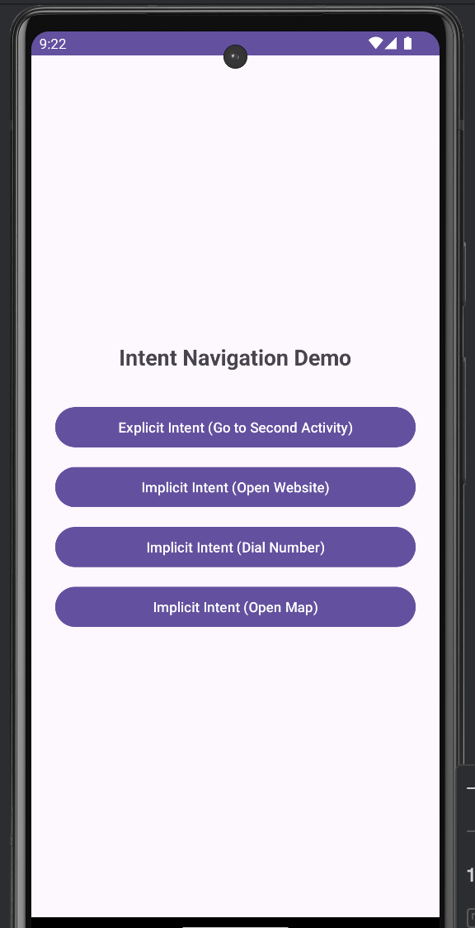

Q7 -> Create an activity to create option Menu.
Ans7 ->

Xml (activity_main.xml) -

<?xml version="1.0" encoding="utf-8"?>
<LinearLayout xmlns:android="http://schemas.android.com/apk/res/android"
android:layout_width="match_parent"
android:layout_height="match_parent"
android:orientation="vertical"
android:gravity="center"
android:padding="24dp">

<TextView
android:id="@+id/tvResult"
android:layout_width="wrap_content"
android:layout_height="wrap_content"
android:text="Select an option from the menu"
android:textSize="20sp"
android:gravity="center"
android:textStyle="bold"/>

</LinearLayout>
Xml (menu_options.xml) -

<?xml version="1.0" encoding="utf-8"?>
<menu xmlns:android="http://schemas.android.com/apk/res/android">

<item
android:id="@+id/menu_home"
android:title="Home"
android:icon="@android:drawable/ic_menu_today"
android:showAsAction="ifRoom"/>

<item
android:id="@+id/menu_search"
android:title="Search"
android:icon="@android:drawable/ic_menu_search"
android:showAsAction="ifRoom"/>

<item
android:id="@+id/menu_settings"
android:title="Settings"
android:icon="@android:drawable/ic_menu_preferences"
android:showAsAction="never"/>

<item
android:id="@+id/menu_share"
android:title="Share"
android:icon="@android:drawable/ic_menu_share"
android:showAsAction="never"/>

<item
android:id="@+id/menu_about"
android:title="About"
android:icon="@android:drawable/ic_menu_info_details"
android:showAsAction="never"/>

<item
android:id="@+id/menu_exit"
android:title="Exit"
android:icon="@android:drawable/ic_menu_close_clear_cancel"
android:showAsAction="never"/>

</menu>

Java -

package com.example.q7optionmenu;

import androidx.appcompat.app.AlertDialog;
import androidx.appcompat.app.AppCompatActivity;
import android.os.Bundle;
import android.view.Menu;
import android.view.MenuItem;
import android.widget.TextView;
import android.widget.Toast;

public class MainActivity extends AppCompatActivity {

TextView tvResult;

@Override
protected void onCreate(Bundle savedInstanceState) {
super.onCreate(savedInstanceState);
setContentView(R.layout.activity_main);

tvResult = findViewById(R.id.tvResult);
}

// Inflate the menu
@Override
public boolean onCreateOptionsMenu(Menu menu) {
getMenuInflater().inflate(R.menu.menu_options, menu);
return true;
}

// Handle menu item clicks
@Override
public boolean onOptionsItemSelected(MenuItem item) {
int id = item.getItemId();

if (id == R.id.menu_home) {
tvResult.setText("You selected: Home");
Toast.makeText(this, "Home selected", Toast.LENGTH_SHORT).show();
return true;

} else if (id == R.id.menu_search) {
tvResult.setText("You selected: Search");
Toast.makeText(this, "Search selected", Toast.LENGTH_SHORT).show();
return true;

} else if (id == R.id.menu_settings) {
tvResult.setText("You selected: Settings");
Toast.makeText(this, "Settings selected", Toast.LENGTH_SHORT).show();
return true;

} else if (id == R.id.menu_share) {
tvResult.setText("You selected: Share");
Toast.makeText(this, "Share selected", Toast.LENGTH_SHORT).show();
return true;

} else if (id == R.id.menu_about) {
// Show About dialog
new AlertDialog.Builder(this)
.setTitle("About")
.setMessage("This is Question 7 - Option Menu App\nDeveloped for Android Lab")
.setPositiveButton("OK", null)
.show();
return true;

} else if (id == R.id.menu_exit) {
// Show exit confirmation dialog
new AlertDialog.Builder(this)
.setTitle("Exit")
.setMessage("Are you sure you want to exit?")
.setPositiveButton("Yes", (dialog, which) -> finish())
.setNegativeButton("No", null)
.show();
return true;
}

return super.onOptionsItemSelected(item);
}
}

Output -

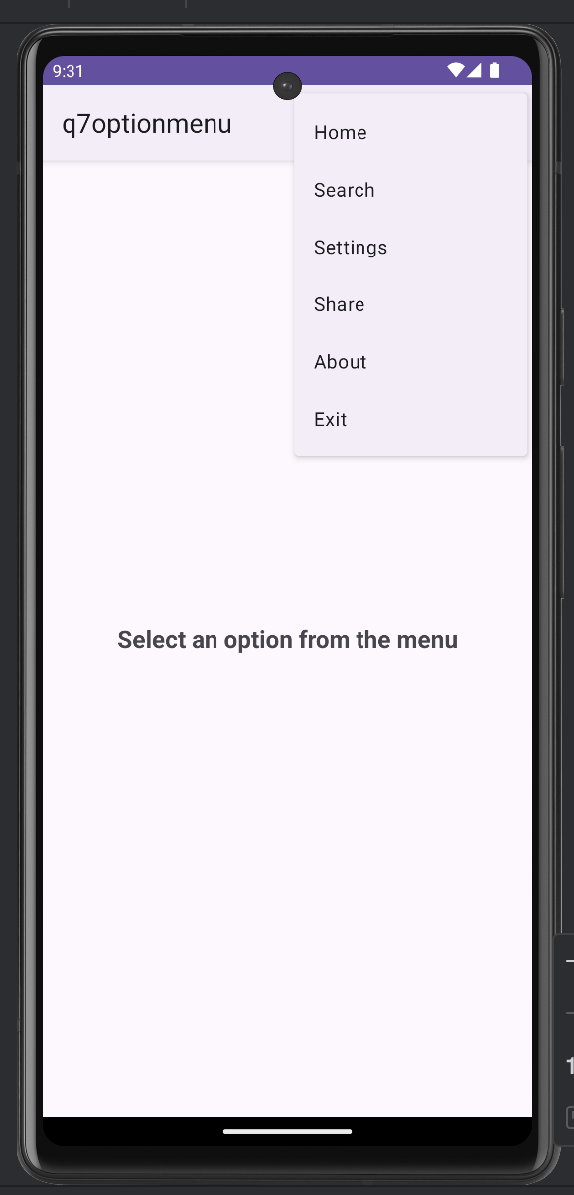
Q8 -> Create an activity using Button Controls- CheckBox, RadioButtons, Radio Groups
Ans8 ->

Xml -
<?xml version="1.0" encoding="utf-8"?>
<ScrollView xmlns:android="http://schemas.android.com/apk/res/android"
android:layout_width="match_parent"
android:layout_height="match_parent">

<LinearLayout
android:layout_width="match_parent"
android:layout_height="wrap_content"
android:orientation="vertical"
android:padding="24dp">

<!-- CHECKBOXES -->
<TextView
android:layout_width="wrap_content"
android:layout_height="wrap_content"
android:text="Select Hobbies (CheckBox):"
android:textSize="18sp"
android:textStyle="bold"/>

<CheckBox
android:id="@+id/cbReading"
android:layout_width="wrap_content"
android:layout_height="wrap_content"
android:text="Reading"/>

<CheckBox
android:id="@+id/cbCoding"
android:layout_width="wrap_content"
android:layout_height="wrap_content"
android:text="Coding"/>

<CheckBox
android:id="@+id/cbGaming"
android:layout_width="wrap_content"
android:layout_height="wrap_content"
android:text="Gaming"/>

<CheckBox
android:id="@+id/cbTravelling"
android:layout_width="wrap_content"
android:layout_height="wrap_content"
android:text="Travelling"/>

<!-- RADIO BUTTONS -->
<TextView
android:layout_width="wrap_content"
android:layout_height="wrap_content"
android:text="Select Gender (RadioButton):"
android:textSize="18sp"
android:textStyle="bold"
android:layout_marginTop="20dp"/>

<RadioGroup
android:id="@+id/rgGender"
android:layout_width="wrap_content"
android:layout_height="wrap_content"
android:orientation="horizontal">

<RadioButton
android:id="@+id/rbMale"
android:layout_width="wrap_content"
android:layout_height="wrap_content"
android:text="Male"/>

<RadioButton
android:id="@+id/rbFemale"
android:layout_width="wrap_content"
android:layout_height="wrap_content"
android:text="Female"/>

<RadioButton
android:id="@+id/rbOther"
android:layout_width="wrap_content"
android:layout_height="wrap_content"
android:text="Other"/>

</RadioGroup>

<!-- RADIO GROUP — Age Range -->
<TextView
android:layout_width="wrap_content"
android:layout_height="wrap_content"
android:text="Select Age Range (RadioGroup):"
android:textSize="18sp"
android:textStyle="bold"
android:layout_marginTop="20dp"/>

<RadioGroup
android:id="@+id/rgAge"
android:layout_width="wrap_content"
android:layout_height="wrap_content"
android:orientation="vertical">

<RadioButton
android:id="@+id/rbAge1"
android:layout_width="wrap_content"
android:layout_height="wrap_content"
android:text="Below 18"/>

<RadioButton
android:id="@+id/rbAge2"
android:layout_width="wrap_content"
android:layout_height="wrap_content"
android:text="18 - 25"/>

<RadioButton
android:id="@+id/rbAge3"
android:layout_width="wrap_content"
android:layout_height="wrap_content"
android:text="26 - 35"/>

<RadioButton
android:id="@+id/rbAge4"
android:layout_width="wrap_content"
android:layout_height="wrap_content"
android:text="Above 35"/>

</RadioGroup>

<!-- SUBMIT BUTTON -->
<Button
android:id="@+id/btnSubmit"
android:layout_width="match_parent"
android:layout_height="wrap_content"
android:layout_marginTop="24dp"
android:text="Submit"/>

<!-- RESULT -->
<TextView
android:id="@+id/tvResult"
android:layout_width="wrap_content"
android:layout_height="wrap_content"
android:layout_marginTop="16dp"
android:textSize="16sp"
android:textStyle="bold"/>

</LinearLayout>
</ScrollView>

Java -
package com.example.q8controls;

import androidx.appcompat.app.AppCompatActivity;
import android.os.Bundle;
import android.view.View;
import android.widget.*;

public class MainActivity extends AppCompatActivity {

CheckBox cbReading, cbCoding, cbGaming, cbTravelling;
RadioGroup rgGender, rgAge;
Button btnSubmit;
TextView tvResult;

@Override
protected void onCreate(Bundle savedInstanceState) {
super.onCreate(savedInstanceState);
setContentView(R.layout.activity_main);

cbReading = findViewById(R.id.cbReading);
cbCoding = findViewById(R.id.cbCoding);
cbGaming = findViewById(R.id.cbGaming);
cbTravelling = findViewById(R.id.cbTravelling);
rgGender = findViewById(R.id.rgGender);
rgAge = findViewById(R.id.rgAge);
btnSubmit = findViewById(R.id.btnSubmit);
tvResult = findViewById(R.id.tvResult);

btnSubmit.setOnClickListener(new View.OnClickListener() {
@Override
public void onClick(View v) {

// Get selected hobbies
String hobbies = "";
if (cbReading.isChecked()) hobbies += "Reading, ";
if (cbCoding.isChecked()) hobbies += "Coding, ";
if (cbGaming.isChecked()) hobbies += "Gaming, ";
if (cbTravelling.isChecked()) hobbies += "Travelling, ";
if (hobbies.isEmpty()) hobbies = "None";
else hobbies = hobbies.substring(0, hobbies.length() - 2);

// Get selected gender
int genderId = rgGender.getCheckedRadioButtonId();
String gender = "Not selected";
if (genderId != -1) {
RadioButton rb = findViewById(genderId);
gender = rb.getText().toString();
}

// Get selected age range
int ageId = rgAge.getCheckedRadioButtonId();
String ageRange = "Not selected";
if (ageId != -1) {
RadioButton rb = findViewById(ageId);
ageRange = rb.getText().toString();
}

// Display result
tvResult.setText(
"Hobbies: " + hobbies + "\n" +
"Gender: " + gender + "\n" +
"Age Range: " + ageRange
);
}
});
}
}

Output -

